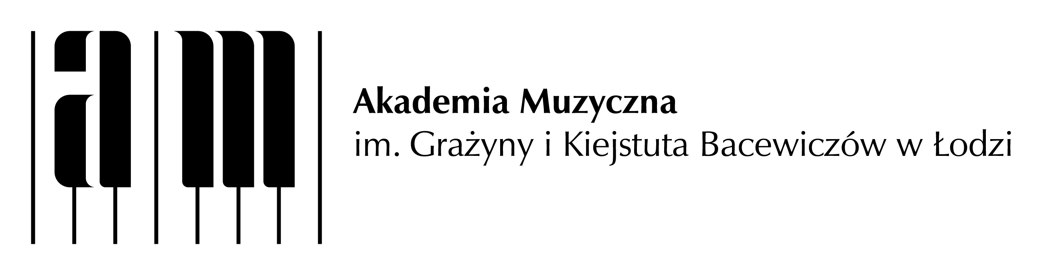

**1st CLARINET-BASSOON FORUM IN ŁÓDŹ**

**APPLICATION FORM**

First name:…………………………………………. Surname: ………………………………………………………………….

City/town: ……………………………………………………………………………………………………………………………...

Higher education institution/School: ………………………………………………………………………………………

Instrument:…………………………………… ……………………………………………………………………………………….

How long you have been playing the instrument (in years):…………………………………………………….

Form of participation: active/passive* | Applying together with a clarinetist/bassoonist*:

Name and surname:…………………………………………..

Contact phone number:………………………………….. e-mail address:……………………………………………

**ACTIVE PARTICIPANT (PROGRAM SELECTION)**

|  |  |  |
| --- | --- | --- |
| **Program for the workshop in orchestral or/and chamber studies** | **Choose your program and tick the appropriate box** | **Put the number of lessons you want to allot to a given work\*\*** |
| M. Rimsky-Korsakov – Scheherazade |  |  |
| P. Tchaikovsky – 5th Symphony |  |  |
| L. van Beethoven – Three duos |  |  |
| F. Poulenc – Sonata for clarinet and bassoon |  |  |
| M. Glinka – Trio pathétique in D minor |  |  |
| R. Strauss – Concertino Duo |  |  |

**\***mark as appropriate

**out of 10 lessons (45-minute long each)

………………………………………………………….

Signature